

Earthquakes: Teacher note
Earthquakes are the sudden shaking or movement of the ground caused by movements in Earth’s surface or crust as a result of rocks breaking underground. This usually occurs along an underground surface called a ‘fault plane’ where rocks are under stress from forces in Earth’s crust. (Page 2 shows the types of rock movements that may occur as the stress is released.) The point within Earth at which the earthquake originated is called the ‘focus’ or the depth of the earthquake. The ‘epicentre’ is the point on Earth’s surface directly above the focus.
When rocks break along a fault, there is a sudden release of energy which travels away from the epicentre as ‘seismic waves’. It is these energy waves that scientists are able to detect and record using a ‘seismograph’. The seismograph detects and accurately records the motion of the ground or seismic waves. Measurements of the height of the seismic waves and how far away the seismograph is from the epicentre of the earthquake are then used to calculate the magnitude or energy output of the earthquake.
The main earthquake is called the ‘mainshock’. This may be followed by smaller earthquakes that occur in the same general area as the mainshock for days to years after a larger earthquake. Generally aftershocks are related to small underground movements along parts of the fault that slipped during the mainshock and are now settling back into place. Based on recorded data, earthquakes that originate deep underground are less likely to have associated aftershocks than shallow earthquakes.
Australia is a relatively stable region and we experience few earthquakes large enough to cause damage. However, they do happen all the time but are often not even noticed by people until they cause visible damage. Visible effects of earthquakes include:
- shaking of the ground
- displacement of the ground
- tsunami
- landslides
- occasionally volcanic activity.
A ‘tsunami’ is a very large ocean wave caused by an underwater earthquake, volcanic eruption or landslide.
A ‘landslide’ is downward sliding of a mass of earth and rock, usually over a confined area.

The video Earthquakes 101 (National Geographic) http://video.nationalgeographic.com/video/environment/environment-natural-disasters/earthquakes/earthquake-101/ can be used to discuss how an earthquake can become labelled a natural disaster and introduce science terms and definitions. It includes discussing the use of seismographs as devices that collect data about an earthquake.
The videos The Padang, Indonesia earthquake of 2009 (Parts 1 and 2) are good tools for discussing the importance of learning from and preparing and educating communities for an earthquake.
Remind students not all earthquakes or tsunamis are natural disasters but the geological events can affect Earth’s surface.
References:
Website — What is an earthquake? (Geoscience Australia) © Commonwealth of Australia 2015, http://www.ga.gov.au/earthquakes/staticPageController.do?page=about-earthquakes/what-is-an-earthquake
Website — USGS FAQs: Earthquakes (U.S. Geological Survey) http://www.usgs.gov/faq/taxonomy/term/9762
Types of faults
A fault is a fracture in Earth's crust due to movement of opposing blocks of earth. Faults are categorised by the movement of the two blocks of earth relative to each other. The most common fault types are shown below.
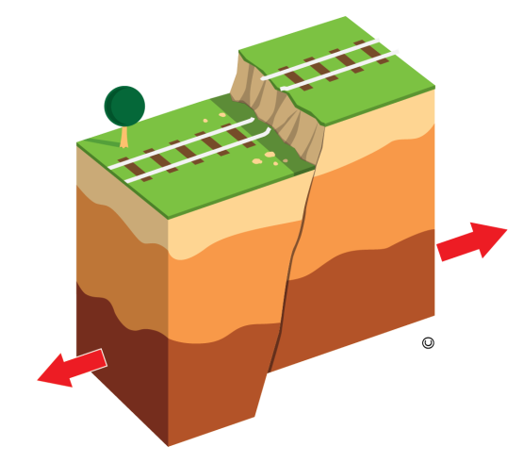 | Normal fault: Blocks are moving away from each other, resulting in one block moving down vertically in comparison to the other block.
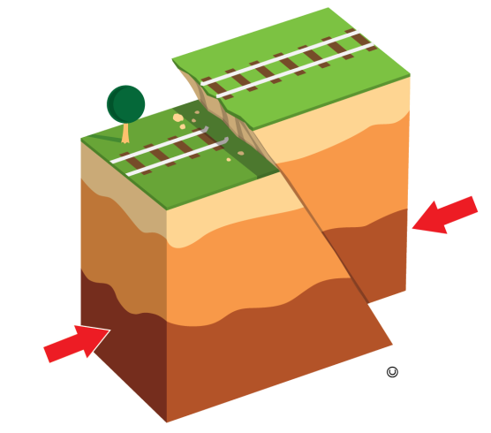 | Thrust fault: Blocks are moving towards each other resulting in one block being pushed up and over the other.
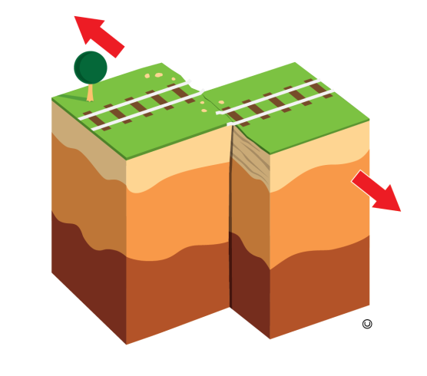 | Strike-slip fault: Blocks move horizontally along a vertical fault line and slide past each other.
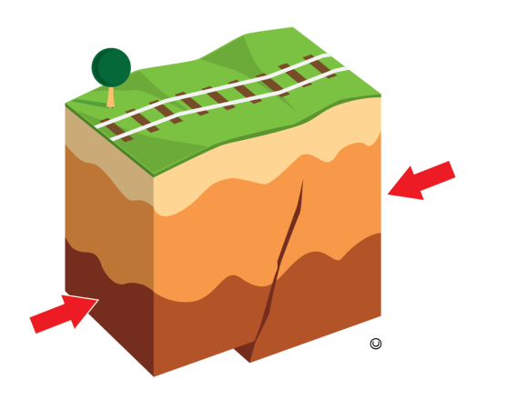 | Blind thrust fault: Blocks are moving towards each other but the movement does not cause the earth surface to break so the fault line is hidden. There is no evidence of an opening but there may be buckling of the earth surface.

